**Prospective Observational Study on Improving the Utility of Clinical Phenotyping In Interstitial Cystitis/Painful Bladder Syndrome At Tertiary Care Unit** (Times New Roman Bold 12, Capitalize Each Word)

# Dr.M.Maria Saroja 1, E.Michael Jeya Priya 2 (Times New Roman 10 Bold)

**1** Principal i/c, Research Director & Associate Professor of Biological Science, Former Controller of Examinations, St. Ignatius College of Education (Autonomous), Palayamkottai.

2 Assistant Professor of Biological Science, St. Ignatius College of Education (Times New Roman 9)

*Corresponding Author:  
Dr.M.Maria Saroja*  
Principal i/c, Research Director & Associate Professor of Biological Science, Former Controller of Examinations, St. Ignatius College of Education (Autonomous), Palayamkottai.E-mail:

**Copyright:** ©2024 Saroja M. This is an open-access article distributed under the terms of the Creative Commons Attribution License, which permits unrestricted use, distribution, and reproduction in any medium, provided the original author and source are credited.

Received: DD-MM-YYYY, Manuscript No. xxxx; Editor Assigned: DD-MM-YYYY, Manuscript No. xxxx; Reviewd: DD-MM-YYYY, Manuscript No. xxxx; Published: DD-MM-YYY

**___________________________________________________________________________________________________**

**ABSTRACT:**

Interstitial cystitis/bladder pain syndrome (IC/BPS) is a debilitating disease that induces mental stress, lower urinary symptoms, and pelvic pain, therefore resulting in a decline in quality of life. The present diagnosis and treatments still lead to unsatisfactory outcomes, and novel diagnostic and therapeutic modalities are needed. The assessment on improving the utility of clinical phenotyping in interstitial cystitis/painful bladder syndrome.

This prospective observational study includes the profile of 62 patients in the Department of urology at Super speciality Hospital Srinagar, one of the associated hospitals of government medical college Srinagar. Patients with CPPS were prospectively classified in each domain of our UPOINT system and the symptoms were measured using the Chronic Prostatitis Symptom Index. Statistical analysis was done using IBM SPSS Statistics for Windows from IBM Corp. (released 2020, Version 27.0. Armonk, NY, USA). Categorical variables were shown in the form of frequencies and percentages. Independent t-test was used. All values were discussed at a 5% level of significance

The percentage of patients positive for the each domain urinary, psychosocial, organ specific, infection, neurologic/systemic, and tenderness domains, respectively was 100%, 69.1%, 100%, 27%, 57.5%, and 29%. Of the 62 patients, 25% were positive for only 1 domain, and a significant stepwise increase was found in the total Chronic Prostatitis Symptom Index score as the number of positive domains increased. A symptom duration of >2 years was associated with an increase in positive domains (P35%-55% decrease in ICSI-29.8 and >50 % decrease in ICSI-71.3 %) was observed in 91.4 % compared with initial baseline visit.

Multimodal therapy using UPOINT leads to significant improvement in symptoms and quality of life. CP/CPPS is a heterogeneous condition and, much like with prostate cancer

(Less than 300 words)

**KEYWORDS:** Healthy Dietary Habits, Cardiovascular Disease, Diabetes, Obesity (Times New Roman 9) (3 – 10 keywords)

# 1. INTRODUCTION (Times New Roman 10 Bold)

Dietary habits are the food choices preferred by persons in their daily life. A healthy dietary habit helps an individual to stay fit and well throughout his life. Healthy diet includes fruits, vegetables, cereals and water, low fat dairy products, etc. **(Sultana.N.2017**). Dietary habits are the habitual decisions an individual or culture makes when choosing what foods to eat. The word diet often implies the use of specific intake of nutrition for health or weight-management reasons. Although humans are omnivores, each culture and each person holds some food preferences or some food taboos. This may be due to personal tastes or ethical reasons. Individual dietary choices may be more or less healthy. Dietary habits and choices play a significant role in the quality of life, health and longevity **( Rayar & Davies 2015**) Good nutrition is an important part of leading a healthy lifestyle. Combined with physical activity, diet can help to reach and maintain a healthy weight, reduce risk of chronic diseases (like heart disease and cancer), and promote overall health. (**Ngozi.M. et al.,2017)** These include heart disease, hypertension (high blood pressure), type 2 diabetes, osteoporosis, and certain types of cancer. By making smart food choices, can help protect ourselves from these health problems. The risk factors for adult chronic diseases, like hypertension and type 2 diabetes, are increasingly seen in younger ages, often a result of unhealthy eating habits and increased weight gain. Dietary habits established in childhood often carry into adulthood, so teaching children how to eat healthy at a young age will help them stay healthy throughout their life. (**Adonova.A.2014)** The link between good nutrition and healthy weight, reduced chronic disease risk, and overall health is too important to ignore. Apart from the lack of nutrients, the outside sourced breakfast is also bound to contain substandard ingredients such as poor quality cooking oil and expired ingredients. Awareness about proper nutrition and healthy dietary habits can make a difference in the society. So it’s a need of an hour to increase healthy dietary awareness among prospective teachers. (Times New Roman 10)

# 2. MATERIALS AND METHODS

Prospective teachers are at risk for making poor dietary choices that can cause significant health problems. They are unaware of the nutritional requirements to maintain a healthy body weight, they make poor nutritional decision, which can cause poor weight management and health problems. Prospective teachers select food according to convenience, taste, time, and price rather than nutritional values. Poor nutrition due to unhealthy eating habits may lead to delayed puberty, nutrient deficiencies and dehydration, menstrual irregularities, poor bone health, increased risk of injuries, poor academic performance and increased risk of eating disorders. The student teachers who are nutrition under eaters may be affected by anorexia or bulimia. Prospective teachers who do not eat breakfast, or eat an insufficient breakfast, are more likely to have behavioral, emotional and academic problems at college. Prospective teachers who consume unhealthy foods can have trouble concentrating, become easily fatigued, listless or irritable and are likely to face difficulties in learning, which can lead to behavioral and social problems. Teaching prospective teachers about the importance of good nutrition lay the foundation for a healthier and more fulfilling life. Poor eating habits and nutritional knowledge deficits may affect health of the youngsters. Healthy eating habits may help to eliminate carbonated soft drinks and unhealthy junk foods from their routine diets. The high intake of sugar rich and white flour foods such as cookies and cakes will increase the risk of obesity among college students. The significance of this research is to enlighten the prospective teachers about the importance of healthy dietary habits.

**3. RESULTS**

The age of study patients vary from 24 years to 80 years with mean age of distribution was 49.3 years ‡ 11.21 years. Maximum number of study patients lied between the age of 47 to 57 years. There were more females (75.80%) in the study as compared to males (24.1%)

**Table.1.** showing the percentage level of awareness on the dietary habits among prospective teachers in Tirunelveli District**.**

|  |  |  |  |  |  |  |
| --- | --- | --- | --- | --- | --- | --- |
| **Awareness on the dietary habits** | **Low** | | **Average** | | **High** | |
| N | % | N | % | N | % |
| 57 | 22.80 | 141 | 56.40 | 52 | 20.80 |

**Figure. A** showing the percentage level of the awareness on healthy dietary habits among prospective teachers in Tirunelveli district.

On clinical examination the most commonly observed symptom was pelvic tenderness (11.29% fallowed by prostrate grade 2 (3.22%) and Grade 2 cystocoele 1.61% (Table 2). With regard to Signs and symptoms on evaluation 100% of patients had complaints of frequency urination, nocturia and urgency (96.77). 30.64% of patients represented with Suprapubic pain fallowed by haematuria (14.51%), burning micturition (11.29%), dysuria (8.06%), difficulty voiding (4.83) and Fever (3.22%) among the study population.

**Table.2.** Difference between male and female prospective teachers in their awareness on healthy dietary habits.

|  |  |  |  |  |  |  |  |
| --- | --- | --- | --- | --- | --- | --- | --- |
| **Variable** | **Categories** | **N** | **Mean** | **SD** | **Calculated ‘t’ Value** | **Table Value** | **Remark** |
| Gender | Male | 133 | 61.71 | 7.41 | 0.80 | 1.96 | NS |
| Female | 117 | 61.03 | 5.89 |

The age of study patients vary from 24 years to 80 years with mean age of distribution was 49.3 years ‡ 11.21 years. Maximum number of study patients lied between the age of 47 to 57 years. There were more females (75.80%) in the study as compared to males (24.1%).

**Figure. B.** Showing the awareness on healthy dietary habits among prospective teachers in Tirunelveli District

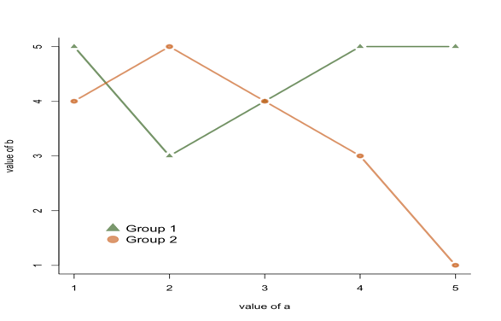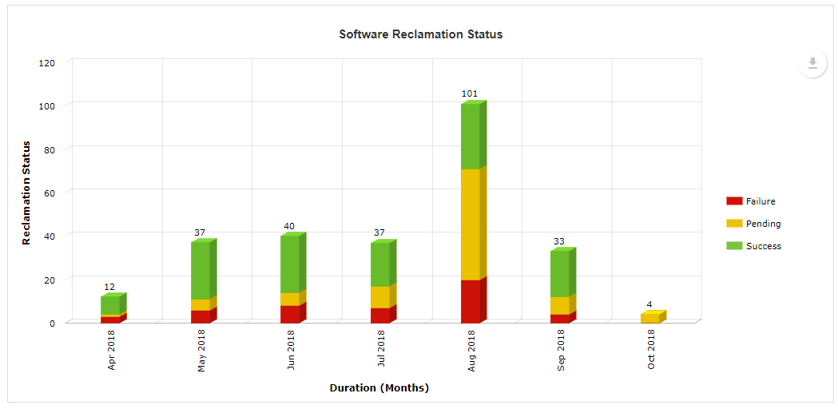

C D

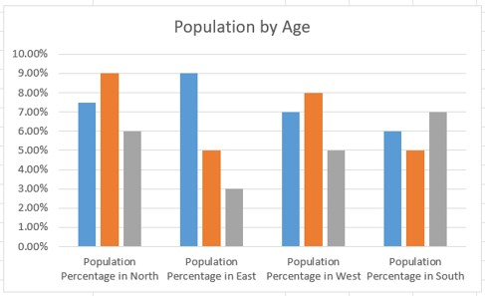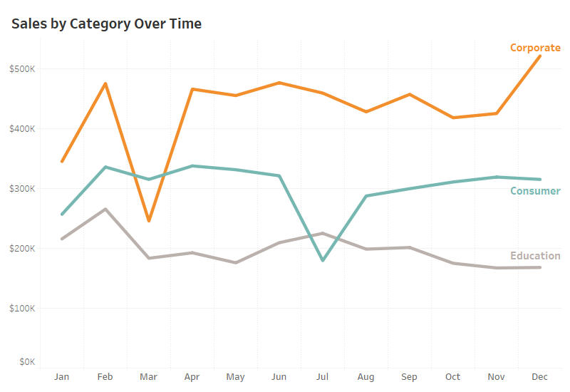

**E F**

**Figure. C.** Treatment received by study population.

**Figure.** D. Response to Treatment

**Figure.** E. UPOINT score

**Figure. F.** Population by Age

# 4. DISCUSSION

Maria Saroja, M.,& Michael Jeya Priya,E (2020) conducted study on the detrimental effects of soft drinks consumption among college students in Tirunelveli District. In their study they find out that there is a significant difference in the gender and type of family in their awareness on the detrimental effects of soft drinks consumption among college students. Abraham, S., Noriega, B.R., & Shin, J.Y (2018) conducted a study on college students eating habits and knowledge of nutritional requirements. Quantitative, cross sectional study with descriptive study was used in this study. In their study they showed that students have a fair knowledge of nutritional requirements for health. Maria Saroja, M., & Michael Jeya Priya, E (2018) conducted a study on awareness on ill effects of junk food among college students in Tirunelveli District. In this study they revealed that, there was a significant difference among higher secondary students in their awareness about the ill effects of Junk food. Salama,A.A.,& Ismael,N.M(2018) conducted study on the nutritional awareness and dietary practices of college-aged students for developing an effective nutritional educational plan. They conducted cross sectional study among 165 first years under graduate students. The findings of their study revealed that students have poor nutritional knowledge about the macro and micro nutrients. Baseer, Revethi, Ayesha, Ramesh, Hiremath.,& Sreekantha(2015) conducted a cross sectional study at preuniversity college students in Raichur, India. In their findings they showed that unhealthy dietary habits are prevalent among adolescents.

# 5. CONCLUSION

# Multimodal therapy using UPOINT leads to significant improvement in symptoms and quality of life. CP/CPPS is a heterogeneous condition and, much like with prostate cancer, optimal therapy can only be achieved by classifying patients into clinically meaningful phenotypic groups and letting the phenotype drive therapy.

# References

1. Abraham, S, Brooke R. Noriega, Ju Young Shin (2018). College students eating habits and knowledge of nutritional requirements. Journal of Nutrition and Human Health, 2(1), 13-17.
2. Andonova, A. The nutritional habits of female students aged 18 to 25. Trakia Journal of Sciences, 16(1), 235-240.
3. Bargiota, A, et al (2013). Eating habits and factors affecting food choice of adolescents living in rural areas. Hormones, 12(2), 246-253.
4. Baseer,Revathi, Ayesha,S.,(2015) Dietary habits and life style among Pre-universtiy college students in Raichur, India. International Journal of Research in Health Sciences, 2(3), 407-411.
5. Das,B, Evans,E.(2014). Understanding weight management perceptions in first-year college studnets using the health belief model, J Am Coll Health, 62, 488-97.
6. Jingxiong, et al (2006). Influence of grandparents on eating behaviors of young children in Chinese three-generation families. Science Direct, 48(3),377-383,
7. Retrieved from https://www.sciencedirect.com/science/article/pii/S0195666306006325.
8. Saroja,M.M & Priya,E.M.J.(2020). Awareness on detrimental effects of soft drinks consumption among college students in Tirunelveli district. Test Engineering and Management, 83, 7823-7829.
9. Saroja,M.M & Priya,E.M.J.(2018).Awareness on ill effects of junk food among higher secondary students in Tirunelveli district. International Research Journal of Mnaagement Sociology and Humanity,8(10), 79-87.
10. Ngozi, E., (2017). Alcohol consumption and awareness of its effects on health among secondary school students in Nigeria, 96(48), E8960
11. Rayar, O & Davies, J., (1996). Cross-culture aspects of eating disorders in Asian girls. Nutrition & Food Science, 96(4), 19-22.
12. Salama,A.A & Ismael,N.M.(2018). Assessing Nutritional Awareness and Dietary Practies of College-aged students for developing an Effective Educational Plan. Canad J Clin Nutr, 6(2), 22-42.
13. Sultana, N. (2017). Nutritional Awareness among the Parents of Primary School going Children. Saudi J. Humanities Soc. Sci., 2(8), 708-725
14. https://www.researchgate.net/publication/322925099_College_Students'_Eating_Habits_and_Knowledge_of_Nutritional_Requirements
15. https://www.researchgate.net/publication/6632641_Influence_of_Grandparents_on_Eating_Behaviors_of_Young_Children_in_Chinese_Three-generation_Families
16. Kaur S, Kapil U, Singh P. Pattern of chronic diseases amongst adolescent obese children in developing countries. Curr Sci. 2005; 88:1052–6.
17. Khadilkar VV, Khadilkar AV. Prevalence of obesity in affluent school boys in Pune. Indian Pediatr. 2004; 41:857–8. [PubMed]
18. Kapil U, Singh P, Pathak P, Dwivedi SN, Bhasin S. Prevalence of obesity amongst affluent adolescent school children in Delhi. Indian Pediatr. 2002; 39:449–52